WORKSHOP 6 Constructive Alignments
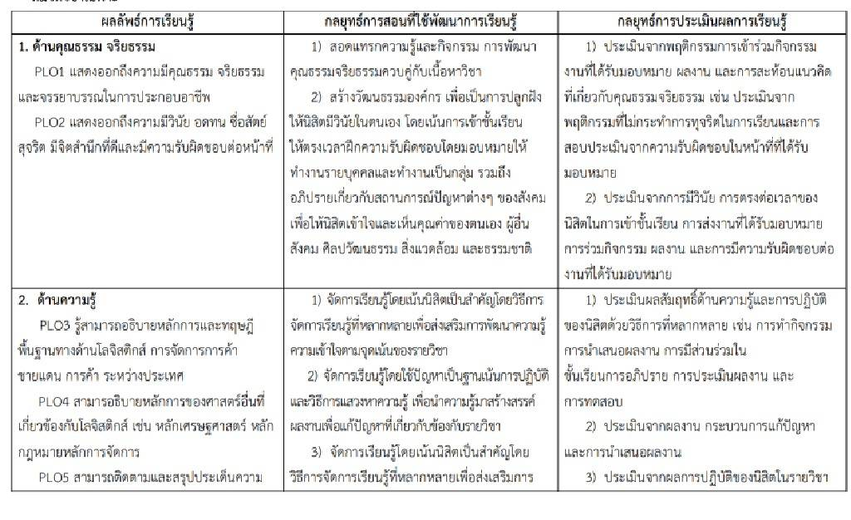
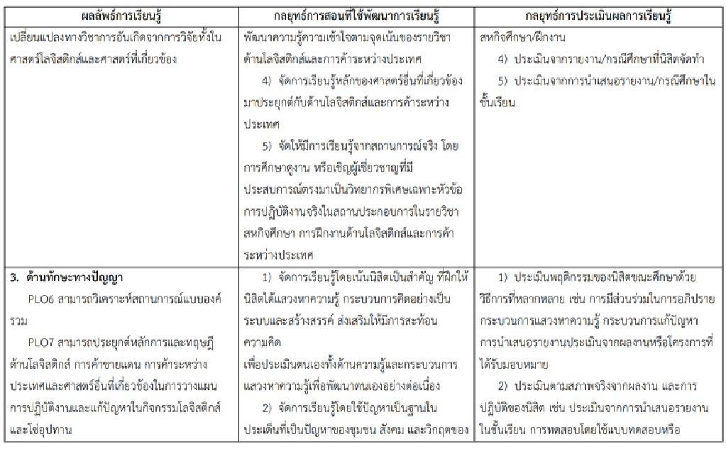
PLOs | Teaching Methods/  Learning Activity | Assessment
PLO1

PLO2

PLO3

PLO4

PLO5

PLO6

PLO7

PLO8

PLO9

PLO10

